Living Blue – Marine Reserves – Vocabulary
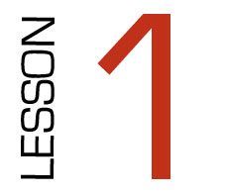

Taboo

RESERVE  - Park  - Sanctuary  - Protected area | ECOSYSTEM  - Environment  - Plants and animals | SUSTAINABLE  - Maintainable  - Goes on and on  - Healthy environment | BIODIVERSITY  - Interconnected plants and animals  - A wide range of species | SPECIES  - Classes  - Types  - Variety and groups
ENDANGERED  - Threatened  - Rare/vanishing  - In danger of extinction | HABITATS  - Homes  - Environments  - Surroundings | PROTECTED  - Safe  - Sheltered  - Shielded | KAITIAKITANGA  - Guardianship  - Benefits future generations  - Maori word | CO-GOVERNANCE  - Share  - Decisions  - Management

