Living Blue – Marine Reserves – Vocabulary
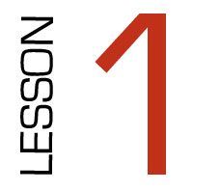

Learning Outcomes: Learn and understand new vocabulary
related to Marine Reserves.

Key Competencies: Thinking, Relating to Others, Using Language,
Symbols and Text, Managing Self, Participating and Contributing.

Resources Used:
- Wordfind
- Purpose discussion
- Definitions – mix/match and draw
- TABOO game

Time | Teacher Instructions / Student activity | Resources | To Photocopy
10mins | Hand out word find as a starter activity. | Wordfind | Class set
10mins | Discuss purpose of lesson and topic – Prior knowledge: Teacher look at question sheet. Ask questions and generally discuss what students already know and perceptions about Marine Reserves. Guideline answers for teacher on question sheet. | Teacher question sheet
20mins | Vocab and Definitions: Hand out ‘definitions mix n match’ sheet. Get students to fold page in half so they cannot see the definitions. Look at the word and ask if anyone knows what it means. After a discussion, look at definition. Discuss, a word then students quickly draw an image in the box beside the word that represents that word for them – when finished share images and why you chose that image with rest of class. | Definitions mix n match  Hand out | Class set
5mins | In books create a sentence using three of the words from the definitions page. Ask for volunteers to share their sentences with class.
10mins | TABOO; Groups of four. Collect a set of cards, card divided equally around group, take turns in being the reader. The top word is the TABOO word, it cannot be said by the reader. The reader reads one of the bottom words at a time as clues untill the TABOO word is guessed by the group. | TABOO cards. 5 sets.
HOMEWORK | At home discuss with parents the three new words you have learnt today and what they mean.

